**Angeles  City Science High School**

**Science 9**

**Name:** Paul Gerald D. Pare **Section:** 9 - Adenine

### Activity 1: Mix and Match in The Mole

Direction**:** Match the correct and related words/concepts from the mole box below. Write your answers. (16 Pts)

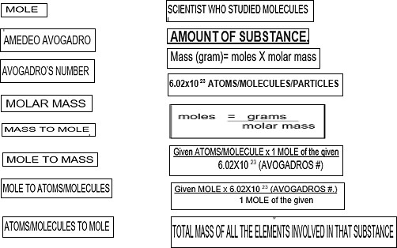

|  |  |
| --- | --- |
| 1.Mole | Amount of Substance |
| 2.Amedeo Avogadro | Scientist who studied molecules |
| 3.Avogadro’s number | 6.02X1023 Atoms/molecules/particles |
| 4.Molar Mass | Total Mass of all the elements involved in the substance |
| 5.Mass to Mole | Moles = |
| 6.Mole to Mass | Mass(gram) = moles X molar mass |
| 7.Mole to Atoms/Molecules |  |
| 8.Atoms/Molecules to Mole |  |

### Activity 2: Go to the mole

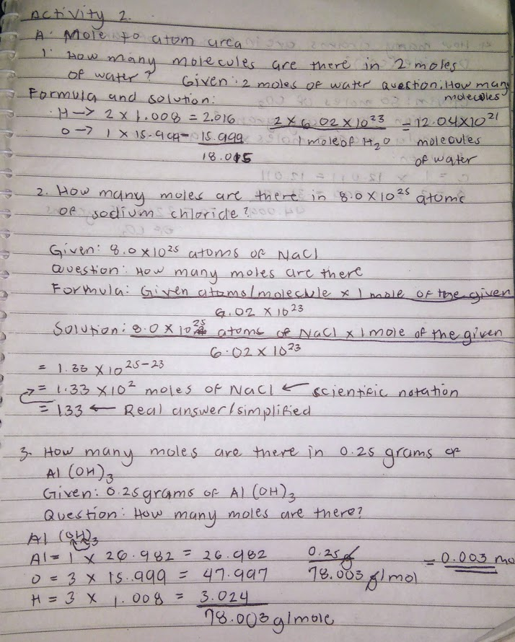

## IMG_256

## ACTIVITY 3: ARE YDU OK IN THE MOLE? (10 pts)

DIRECTION. ANSWER THE FOLLOWING SURVEY QUESTIONS AS HONEST AS POSSIBLE.

1. Did you l earn about MOLE Concept? (yes/no) Why? Yes, but I’m a bit confused, because of similar terms that confuses me but I can understand the process of solving it.
2. What part/s of the MOLE conCept did you enjoy doings? Getting the molar mass is really fun for me because it is so simple yet effective.
3. Can you write what part/s of the MOLE concept did you find it hard to do? I find it hard to do the conversion between atoms/molecules to moles and vise versa because of the exponents and other bits and pieces.